Pet Peeve Paragraph and Presentation

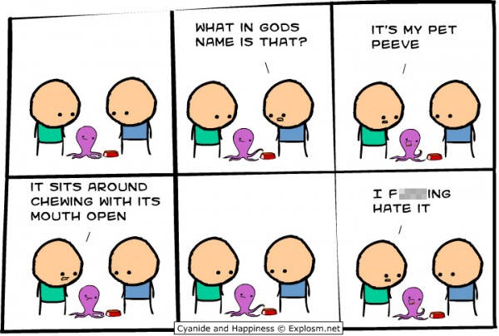
It’s important to get along with people. That’s why we usually suppress our annoyances with some of the things that happen to us. We don’t want to offend others, but this is your chance to say what you really think! Of course, you should not name anyone in your rant. Just tell us what gets under your skin and why.
Is your pet peeve someone who won’t listen to what you say and are only concerned with his or her own perspective? Is it stores that watch your every move when you enter, assuming because you are a teen you must be a security threat? Or is it the pet that chews your most valued possessions when you are away from the house? What ever steams you; you have 1-2 minutes to let it out.
I hate it!
You’ll feel better after you do!
If you don’t feel comfortable baring your soul, feel free make up a pet peeve or adopt a persona. Maybe you would like to write in character. Whatever you do, make sure you convey your personal writing voice.

Be sure to include:
- Pet Peeve Good copy /12 Marks
- Oral Presentation /6 Marks

Prescribed Learning Outcome (PLO) | Not yet within Expectations (1-2) | Minimally Meeting Expectations (3) | Meeting Expectations (4-5) | Exceeding Expectations  (6)
A5 – I can prepare for oral communications. | I struggle with how to organize my thinking in order to prepare for speaking. I am often unprepared. | Before sharing my ideas orally, I have attempted to brainstorm and explore my topic. I have basic organization and limited materials. | Before sharing my ideas orally, I have explored the topic through brainstorming and research. I am organized and prepared with appropriate materials. | Before sharing my ideas orally, I have fully explored the topic through brain storming, research and considering other perspectives. I am organized and prepared with interesting materials.
A6 - I can present my ideas orally in an effective way. | I cannot speak about my topic in a way that can be understood by my audience. There is no variation in my voice and body language. I rely exclusively on memory aids if I have prepared them in advance at all. Visuals may not have been prepared and/or are not effective. | I can speak about my topic. My projection may not be effective or consistent. There is little variation in my voice and body language. I rely heavily on my memory aids. My visuals are lacking or ineffective. | When speaking, I attempt to engage my audience. I have appropriate voice and body language. I speak clearly and have practiced but may rely too much on memory aids. My visuals enhance my speaking. | When speaking, I engage my audience through using my voice and body language. I speak clearly, and fluidly with appropriate emotion. I have clearly practiced, and do not rely solely on memory aids. My visuals enhance my speaking.

Self Evaluation: (2 Stars and 1 Wish)

Two things I did well in my presentation:

One thing I will try to improve for next time:

A11 – I can reflect on and assess my own listening and speaking. | I feel that I am not progressing, and I am unsure what goals to set, or how to improve. I never refer to feedback. | I have made small improvements, but require support in setting goals. I rarely refer to feedback. | I am making good progress and am able to set appropriate goals for improvement. I sometimes refer to feedback. | I can use feedback and consistently identify areas for improvement. Once I have met a goal, I am able to set new goals.

