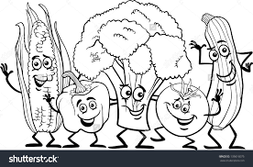
Vegetable Creatures
Name:__________________________________

Your job is to create a vegetable creature, but first you need to know a little something about the vegetable you’ve chosen. Find out what health benefits your vegetable has, where it is grown, what vitamins or minerals are present, how to tell it’s at its peak (look, smell touch of vegetable) etc.

After doing your research complete the following:
- Draw an original picture of your vegetable creature. Don’t be afraid to give it some personality (a sassy squash, a cool cucumber etc.)
- Create a poem that introduces your vegetable to others that highlights the vegetable.
- Be sure to include at least 5 pieces of information in your poem.
- Create a good copy of your vegetable drawing and (error-free) poem.

Notes/Research:

